DriverPass Client Presentation — Slides and Speaker Notes
Ricky Bowman
Slide 1: DriverPass System Analysis
Ricky Bowman
Speaker Notes
No speaker notes are required for the title slide.
Slide 2: System Requirements
Functional requirements:
• Schedule, change, and cancel two-hour lessons
• Provide package-eligible online classes and practice tests
Nonfunctional requirements:
• Secure access based on staff responsibilities
• Browser access from computers and mobile devices
Speaker Notes
DriverPass needs one place for the student to do their DMV test prep and training. Students and office staff can book two-hour lessons, and customers with the right package can take the online practice tests. Security is obviously important, as the staff has different roles. The system will have appropriate access permissions and will be usable via the standard web browsers on both PC and mobile devices.
Slide 3: Use Case Diagram
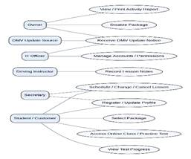
Speaker Notes
This diagram illustrates the way various users interact with DriverPass. The customer registers, selects a package, manages their lessons, and accesses training when appropriate. The secretary assists the customer with the registration and appointment scheduling. The instructor enters the lesson notes. The owner looks at the reports and manages the package availability. The IT officer looks after the accounts. The DMV update notices are used by staff to keep the training information up to date.
Slide 4: Activity Diagram
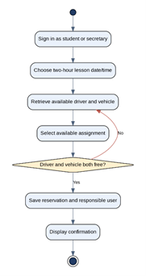
Speaker Notes
This is a diagram of a student/secretary going through the process of booking a driving lesson. They sign in and select a date and time. DriverPass then looks for an available instructor and vehicle for that two-hour period. If there's a conflict, then another option has to be selected. Once a valid appointment has been found, it is saved, and the person who booked it is recorded. This obviously prevents double booking and offers clear records.
Slide 5: Security
• Secure sign-in and password resets
• Different access for customers and employees
• Encrypted connections and protected information
• Records of reservation changes
• Managed backups and recovery
Speaker Notes
The system protects customer data through a sign-in requirement and permission levels based on the individual's role. A customer should not be able to view another customer's private information, and the IT officer would have the ability to manage accounts. Information is protected in transit via secure connections. There is a record of all changes to appointments so that DriverPass can investigate any errors and produce reports. There is cloud backup and recovery in place to reduce the danger of data loss.
Slide 6: System Restrictions
• Changes to records require internet access
• DMV updates depend on an available external feed
• New software modules require future development
• Cloud and outside services may experience outages
• Final capacity and recovery targets need client approval
Speaker Notes
The system has a number of caveats. Staff and students will need internet access in order to make changes, although they can download and view the authorized reports offline. DMV updates will be dependent on information being made available via a supported external source. DriverPass can turn off the existing packages but would require additional development to create new system packages. There will be potential for disruption from the cloud services and other external providers. The client will also need to confirm their expectations in terms of capacity, availability, and recovery prior to launch.

